**ASP.NET MVC Tutorial: Web application development with Azure Cosmos DB**

To highlight how you can efficiently leverage Azure Cosmos DB to store and query JSON documents, this article provides an end-to-end walk-through showing you how to build a todo app using Azure Cosmos DB. The tasks will be stored as JSON documents in Azure Cosmos DB.

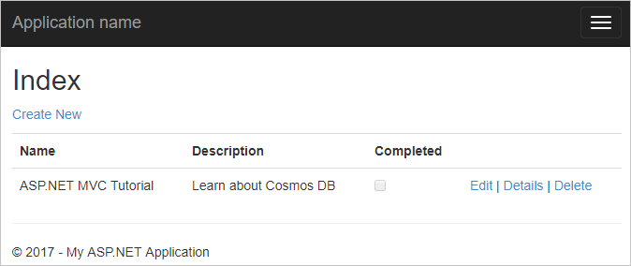

This walk-through shows you how to use the Azure Cosmos DB service to store and access data from an ASP.NET MVC web application hosted on Azure.

**Tip**

This tutorial assumes that you have prior experience using ASP.NET MVC and Azure Websites. If you are new to ASP.NET or the [**prerequisite tools**](https://docs.microsoft.com/en-us/azure/cosmos-db/sql-api-dotnet-application#_Toc395637760), we recommend downloading the complete sample project from **[GitHub](https://github.com/Azure-Samples/documentdb-net-todo-app)** and following the instructions in this sample. Once you have it built, you can review this article to gain insight on the code in the context of the project.

**Prerequisites for this database tutorial**

Before following the instructions in this article, you should ensure that you have the following:

* An active Azure account. If you don't have an Azure subscription, create a [free account](https://azure.microsoft.com/free/?WT.mc_id=A261C142F)before you begin.

You can [Try Azure Cosmos DB for free](https://azure.microsoft.com/try/cosmosdb/) without an Azure subscription, free of charge and commitments. Or, you can use the [Azure Cosmos DB Emulator](https://docs.microsoft.com/azure/cosmos-db/local-emulator) with a URI of [https://localhost:8081](https://localhost:8081/). The Primary Key is provided in [Authenticating requests](https://docs.microsoft.com/en-us/azure/cosmos-db/local-emulator#authenticating-requests).

* If you don’t already have Visual Studio 2017 installed, you can download and use the **free** [Visual Studio 2017 Community Edition](https://www.visualstudio.com/downloads/). Make sure that you enable **Azure development** workload during the Visual Studio setup.
* Microsoft Azure SDK for .NET for Visual Studio 2017, available through the Visual Studio Installer.

All the screen shots in this article have been taken using Microsoft Visual Studio Community 2017. If your system is configured with a different version it is possible that your screens and options won't match entirely, but if you meet the above prerequisites this solution should work.

**Step 1: Create an Azure Cosmos DB database account**

Let's start by creating an Azure Cosmos DB account. If you already have a SQL account for Azure Cosmos DB or if you are using the Azure Cosmos DB Emulator for this tutorial, you can skip to [Create a new ASP.NET MVC application](https://docs.microsoft.com/en-us/azure/cosmos-db/sql-api-dotnet-application#_Toc395637762).

1. In a new browser window, sign in to the [Azure portal](https://portal.azure.com/).
2. Select **Create a resource** > **Databases** > **Azure Cosmos DB**.

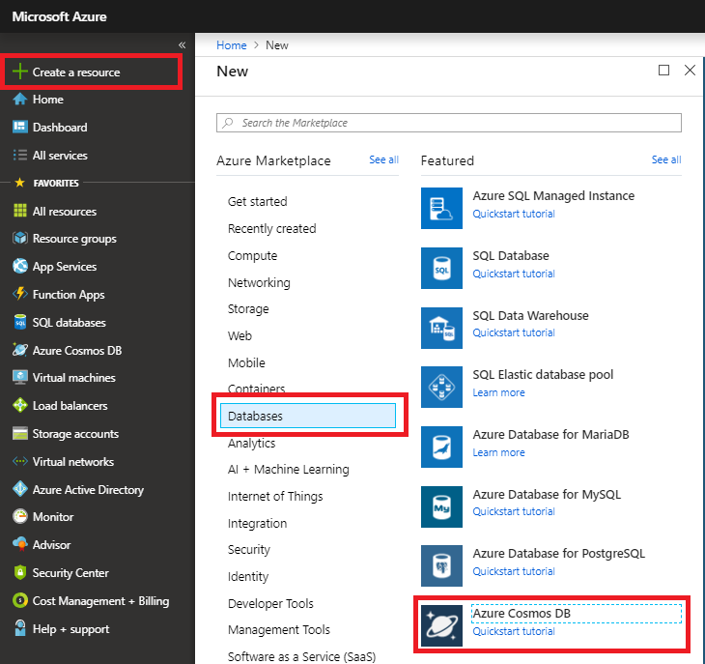

1. On the **Create Azure Cosmos DB Account** page, enter the basic settings for the new Azure Cosmos DB account.

| **Setting** | **Value** | **Description** |
| --- | --- | --- |
| Subscription | Your subscription | Select the Azure subscription that you want to use for this Azure Cosmos DB account. |
| Resource Group | Create new  Then enter the same unique name as provided in ID | Select **Create new**. Then enter a new resource-group name for your account. For simplicity, use the same name as your ID. |
| Account Name | Enter a unique name | Enter a unique name to identify your Azure Cosmos DB account. Because *documents.azure.com* is appended to the ID that you provide to create your URI, use a unique ID.  The ID can only contain lowercase letters, numbers, and the hyphen (-) character. It must be between 3 and 31 characters in length. |
| API | Core(SQL) | The API determines the type of account to create. Azure Cosmos DB provides five APIs: Core(SQL) for document databases, Gremlin for graph databases, MongoDB for document databases, Azure Table, and Cassandra. Currently, you must create a separate account for each API.   Select **Core(SQL)** because in this article you create a document database and query by using SQL syntax.   [Learn more about the SQL API](https://docs.microsoft.com/en-us/azure/cosmos-db/documentdb-introduction). |
| Location | Select the region closest to your users | Select a geographic location to host your Azure Cosmos DB account. Use the location that's closest to your users to give them the fastest access to the data. |

1. Select **Review+Create**. You can skip the **Network** and **Tags** section.
2. 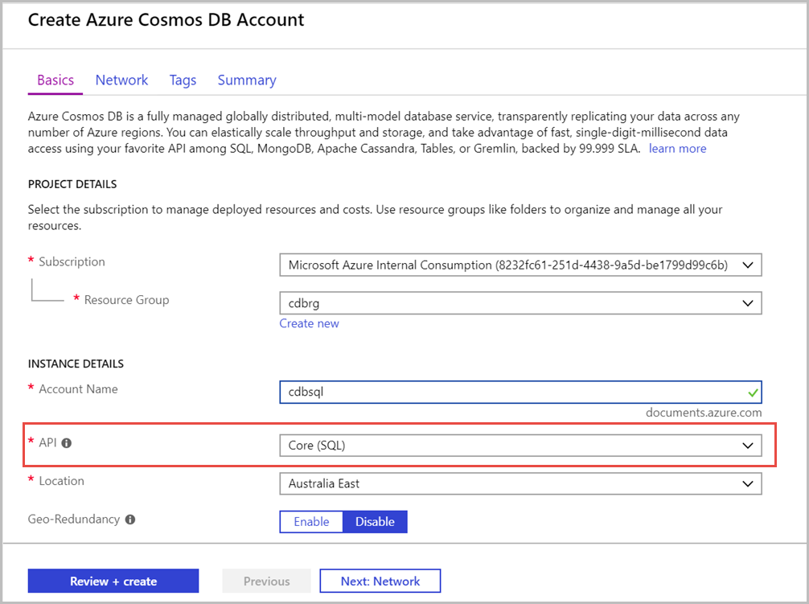
3. The account creation takes a few minutes. Wait for the portal to display the **Congratulations! Your Azure Cosmos DB account was created** page.

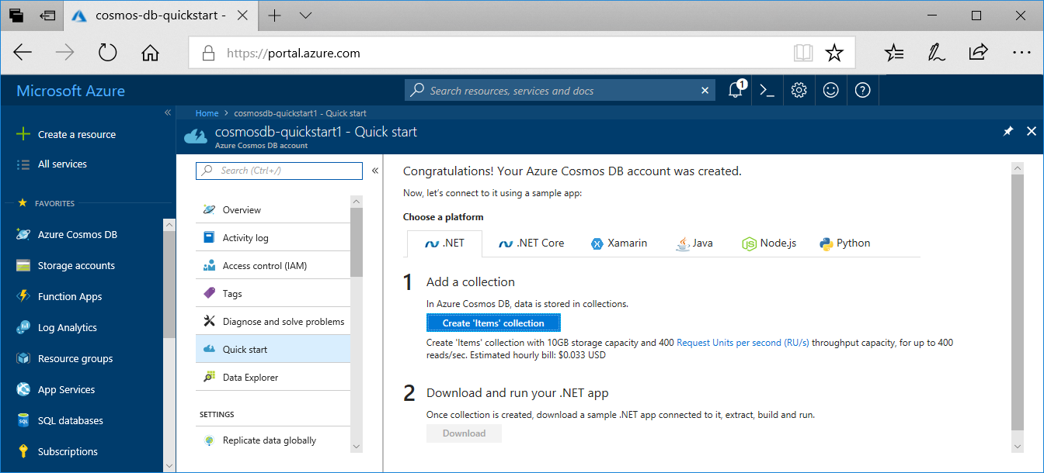

Now navigate to the Azure Cosmos DB account page, and click **Keys**, as these values are used in the web application you create next.

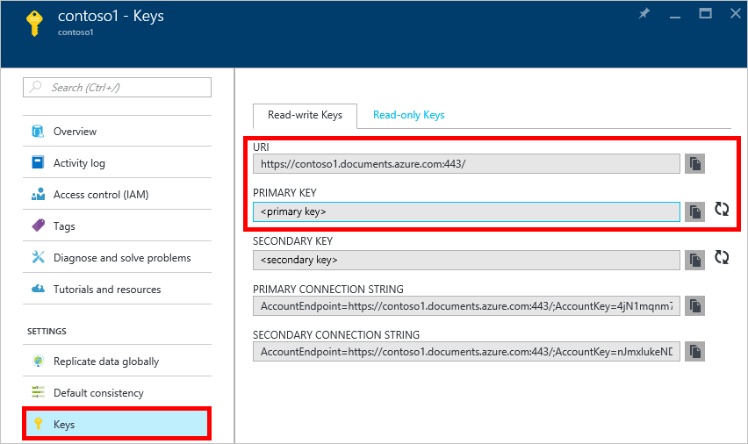

We will now walk through how to create a new ASP.NET MVC application from the ground-up.

**Step 2: Create a new ASP.NET MVC application**

1. In Visual Studio, on the **File** menu, point to **New**, and then click **Project**. The **New Project** dialog box appears.
2. In the **Project types** pane, expand **Templates**, **Visual C#**, **Web**, and then select **ASP.NET Web Application**.

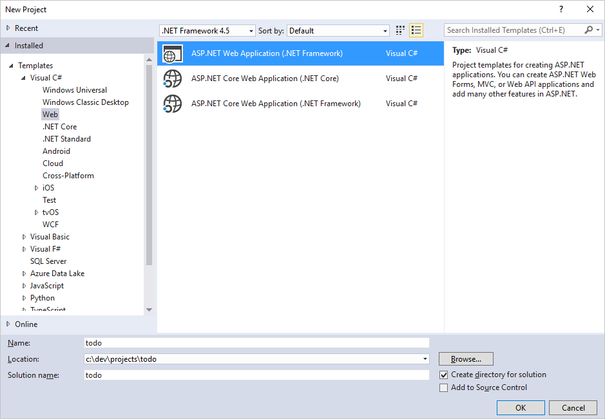

1. In the **Name** box, type the name of the project. This tutorial uses the name "todo". If you choose to use something other than this, then wherever this tutorial talks about the todo namespace, you need to adjust the provided code samples to use whatever you named your application.
2. Click **Browse** to navigate to the folder where you would like to create the project, and then click **OK**.

The **New ASP.NET Web Application** dialog box appears.

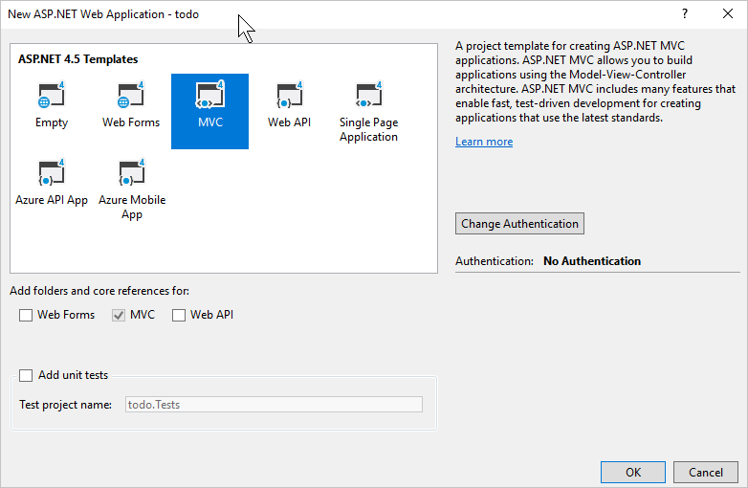

1. In the templates pane, select **MVC**.
2. Click **OK** and let Visual Studio do its thing around scaffolding the empty ASP.NET MVC template.
3. Once Visual Studio has finished creating the boilerplate MVC application you have an empty ASP.NET application that you can run locally.

We'll skip running the project locally because I'm sure we've all seen the ASP.NET "Hello World" application. Let's go straight to adding Azure Cosmos DB to this project and building our application.

**Step 3: Add Azure Cosmos DB to your MVC web application project**

Now that we have most of the ASP.NET MVC plumbing that we need for this solution, let's get to the real purpose of this tutorial, adding Azure Cosmos DB to our MVC web application.

1. The Azure Cosmos DB .NET SDK is packaged and distributed as a NuGet package. To get the NuGet package in Visual Studio, use the NuGet package manager in Visual Studio by right-clicking on the project in **Solution Explorer** and then clicking **Manage NuGet Packages**.

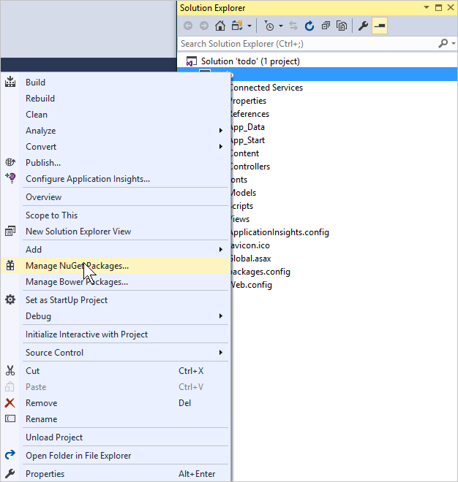

The **Manage NuGet Packages** dialog box appears.

1. In the NuGet **Browse** box, type ***Azure DocumentDB***. (The package name has not been updated to Azure Cosmos DB.)

From the results, install the **Microsoft.Azure.DocumentDB by Microsoft** package. This will download and install the Azure Cosmos DB package as well as all dependencies, such as Newtonsoft.Json. Click **OK** in the **Preview** window, and **I Accept** in the **License Acceptance** window to complete the install.

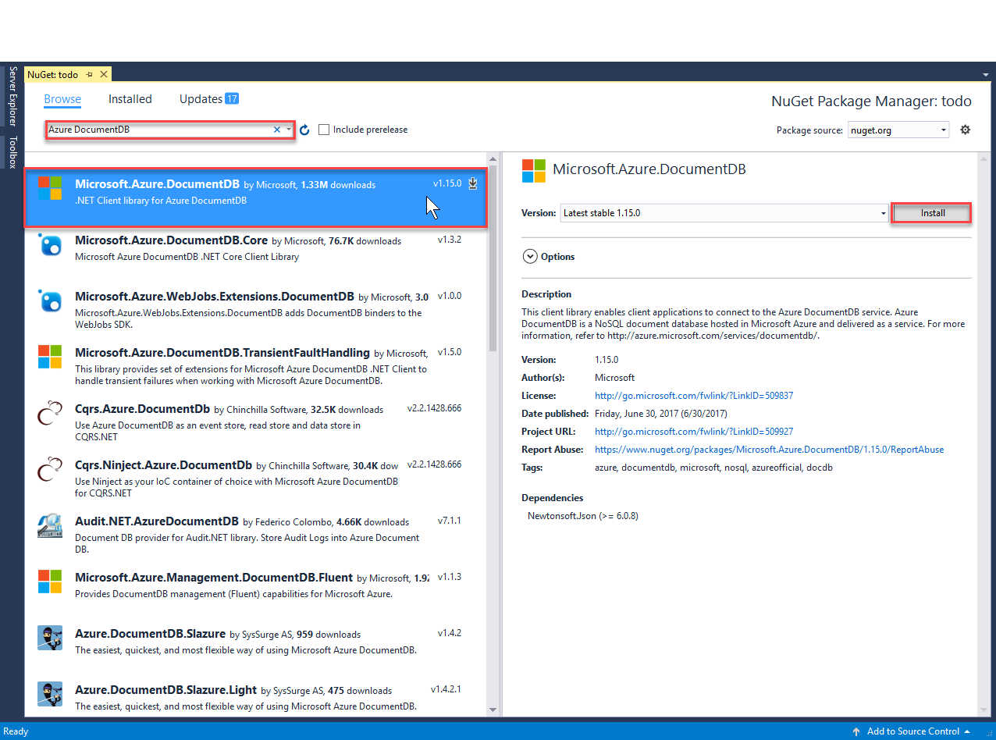

Alternatively you can use the Package Manager Console to install the package. To do so, on the **Tools** menu, click **NuGet Package Manager**, and then click **Package Manager Console**. At the prompt, type the following.

Copy

Install-Package Microsoft.Azure.DocumentDB

1. Once the package is installed, your Visual Studio solution should resemble the following with two new references added, Microsoft.Azure.Documents.Client and Newtonsoft.Json.

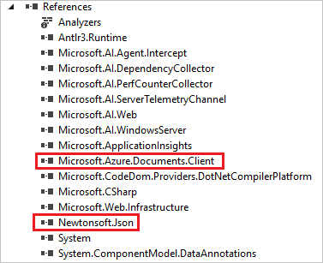

**Step 4: Set up the ASP.NET MVC application**

Now let's add the models, views, and controllers to this MVC application:

* [Add a model](https://docs.microsoft.com/en-us/azure/cosmos-db/sql-api-dotnet-application#_Toc395637764).
* [Add a controller](https://docs.microsoft.com/en-us/azure/cosmos-db/sql-api-dotnet-application#_Toc395637765).
* [Add views](https://docs.microsoft.com/en-us/azure/cosmos-db/sql-api-dotnet-application#_Toc395637766).

**Add a JSON data model**

Let's begin by creating the **M** in MVC, the model.

1. In **Solution Explorer**, right-click the **Models** folder, click **Add**, and then click **Class**.

The **Add New Item** dialog box appears.

1. Name your new class **Item.cs** and click **Add**.
2. In this new **Item.cs** file, add the following after the last *using statement*.

Copy

using Newtonsoft.Json;

1. Now replace this code

Copy

public class Item

{

}

with the following code.

Copy

public class Item

{

[JsonProperty(PropertyName = "id")]

public string Id { get; set; }

[JsonProperty(PropertyName = "name")]

public string Name { get; set; }

[JsonProperty(PropertyName = "description")]

public string Description { get; set; }

[JsonProperty(PropertyName = "isComplete")]

public bool Completed { get; set; }

}

All data in Azure Cosmos DB is passed over the wire and stored as JSON. To control the way your objects are serialized/deserialized by JSON.NET you can use the **JsonProperty**attribute as demonstrated in the **Item** class we just created. You don't **have** to do this but I want to ensure that my properties follow the JSON camelCase naming conventions.

Not only can you control the format of the property name when it goes into JSON, but you can entirely rename your .NET properties like I did with the **Description** property.

**Add a controller**

That takes care of the **M**, now let's create the **C** in MVC, a controller class.

1. In **Solution Explorer**, right-click the **Controllers** folder, click **Add**, and then click **Controller**.

The **Add Scaffold** dialog box appears.

1. Select **MVC 5 Controller - Empty** and then click **Add**.

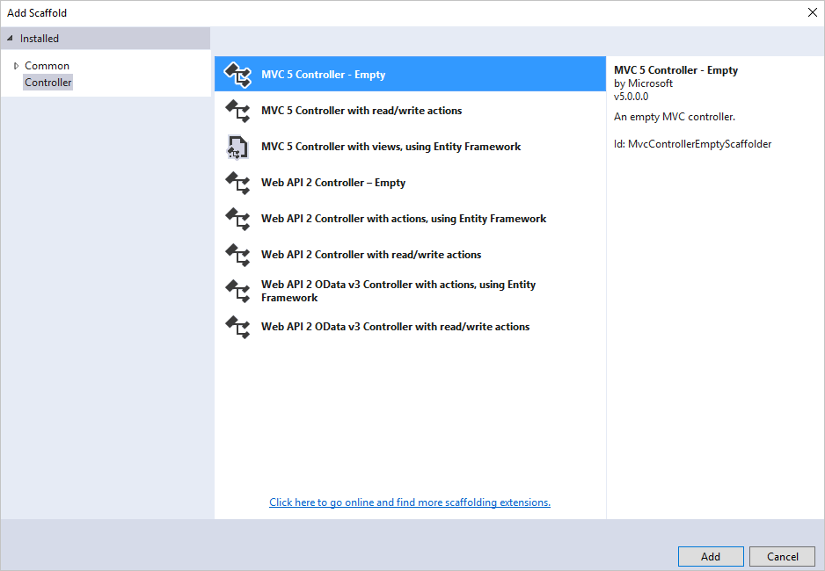

1. Name your new Controller, **ItemController.**

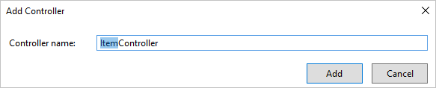

Once the file is created, your Visual Studio solution should resemble the following with the new ItemController.cs file in **Solution Explorer**. The new Item.cs file created earlier is also shown.

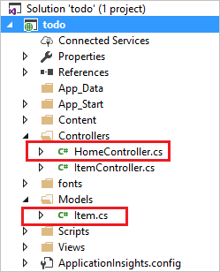

You can close ItemController.cs, we'll come back to it later.

**Add views**

Now, let's create the **V** in MVC, the views:

* [Add an Item Index view](https://docs.microsoft.com/en-us/azure/cosmos-db/sql-api-dotnet-application#AddItemIndexView).
* [Add a New Item view](https://docs.microsoft.com/en-us/azure/cosmos-db/sql-api-dotnet-application#AddNewIndexView).
* [Add an Edit Item view](https://docs.microsoft.com/en-us/azure/cosmos-db/sql-api-dotnet-application#_Toc395888515).

**Add an Item Index view**

1. In **Solution Explorer**, expand the **Views** folder, right-click the empty **Item** folder that Visual Studio created for you when you added the **ItemController** earlier, click **Add**, and then click **View**.

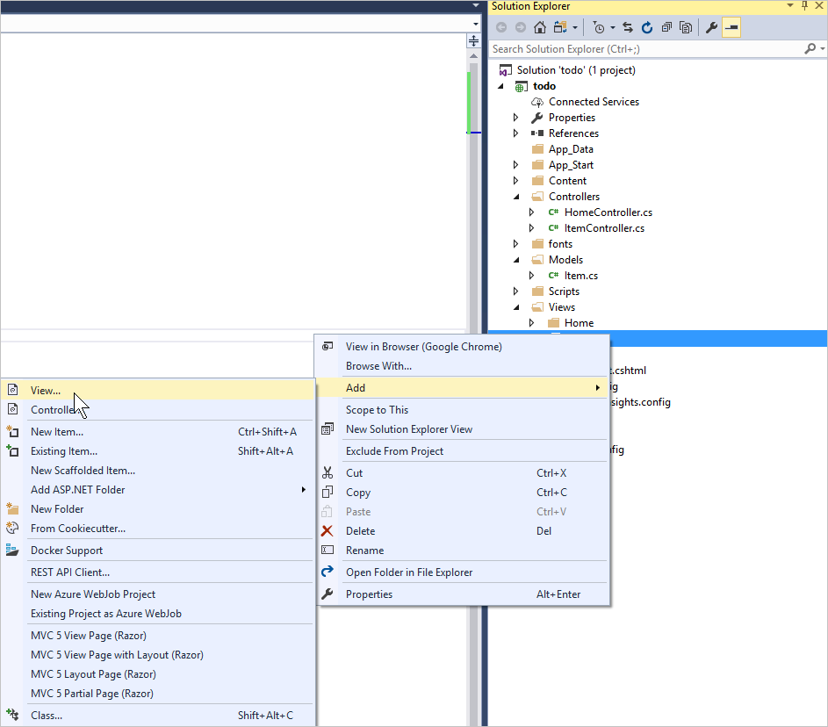

1. In the **Add View** dialog box, do the following:
   * In the **View name** box, type ***Index***.
   * In the **Template** box, select ***List***.
   * In the **Model class** box, select ***Item (todo.Models)***.
   * In the layout page box, type ***~/Views/Shared/_Layout.cshtml***.

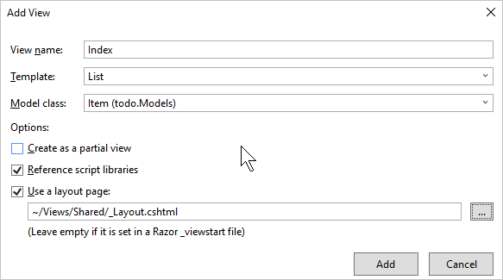

1. Once all these values are set, click **Add** and let Visual Studio create a new template view. Once it is done, it will open the cshtml file that was created. We can close that file in Visual Studio as we will come back to it later.

**Add a New Item view**

Similar to how we created an **Item Index** view, we will now create a new view for creating new **Items**.

1. In **Solution Explorer**, right-click the **Item** folder again, click **Add**, and then click **View**.
2. In the **Add View** dialog box, do the following:
   * In the **View name** box, type ***Create***.
   * In the **Template** box, select ***Create***.
   * In the **Model class** box, select ***Item (todo.Models)***.
   * In the layout page box, type ***~/Views/Shared/_Layout.cshtml***.
   * Click **Add**.

**Add an Edit Item view**

And finally, add one last view for editing an **Item** in the same way as before.

1. In **Solution Explorer**, right-click the **Item** folder again, click **Add**, and then click **View**.
2. In the **Add View** dialog box, do the following:
   * In the **View name** box, type ***Edit***.
   * In the **Template** box, select ***Edit***.
   * In the **Model class** box, select ***Item (todo.Models)***.
   * In the layout page box, type ***~/Views/Shared/_Layout.cshtml***.
   * Click **Add**.

Once this is done, close all the cshtml documents in Visual Studio as we will return to these views later.

**Step 5: Wiring up Azure Cosmos DB**

Now that the standard MVC stuff is taken care of, let's turn to adding the code for Azure Cosmos DB.

In this section, we'll add code to handle the following:

* [Listing incomplete Items](https://docs.microsoft.com/en-us/azure/cosmos-db/sql-api-dotnet-application#_Toc395637770).
* [Adding Items](https://docs.microsoft.com/en-us/azure/cosmos-db/sql-api-dotnet-application#_Toc395637771).
* [Editing Items](https://docs.microsoft.com/en-us/azure/cosmos-db/sql-api-dotnet-application#_Toc395637772).

**Listing incomplete Items in your MVC web application**

The first thing to do here is add a class that contains all the logic to connect to and use Azure Cosmos DB. For this tutorial we'll encapsulate all this logic in to a repository class called DocumentDBRepository.

1. In **Solution Explorer**, right-click on the project, click **Add**, and then click **Class**. Name the new class **DocumentDBRepository** and click **Add**.
2. In the newly created **DocumentDBRepository** class and add the following *using statements* above the *namespace* declaration

Copy

using Microsoft.Azure.Documents;

using Microsoft.Azure.Documents.Client;

using Microsoft.Azure.Documents.Linq;

using System.Configuration;

using System.Linq.Expressions;

using System.Threading.Tasks;

using System.Net;

Now replace this code

Copy

public class DocumentDBRepository

{

}

with the following code.

Copy

public static class DocumentDBRepository<T> where T : class

{

private static readonly string DatabaseId = ConfigurationManager.AppSettings["database"];

private static readonly string CollectionId = ConfigurationManager.AppSettings["collection"];

private static DocumentClient client;

public static void Initialize()

{

client = new DocumentClient(new Uri(ConfigurationManager.AppSettings["endpoint"]), ConfigurationManager.AppSettings["authKey"]);

CreateDatabaseIfNotExistsAsync().Wait();

CreateCollectionIfNotExistsAsync().Wait();

}

private static async Task CreateDatabaseIfNotExistsAsync()

{

try

{

await client.ReadDatabaseAsync(UriFactory.CreateDatabaseUri(DatabaseId));

}

catch (DocumentClientException e)

{

if (e.StatusCode == System.Net.HttpStatusCode.NotFound)

{

await client.CreateDatabaseAsync(new Database { Id = DatabaseId });

}

else

{

throw;

}

}

}

private static async Task CreateCollectionIfNotExistsAsync()

{

try

{

await client.ReadDocumentCollectionAsync(UriFactory.CreateDocumentCollectionUri(DatabaseId, CollectionId));

}

catch (DocumentClientException e)

{

if (e.StatusCode == System.Net.HttpStatusCode.NotFound)

{

await client.CreateDocumentCollectionAsync(

UriFactory.CreateDatabaseUri(DatabaseId),

new DocumentCollection { Id = CollectionId },

new RequestOptions { OfferThroughput = 1000 });

}

else

{

throw;

}

}

}

}

1. We're reading some values from configuration, so open the **Web.config** file of your application and add the following lines under the <AppSettings> section.

Copy

<add key="endpoint" value="enter the URI from the Keys blade of the Azure Portal"/>

<add key="authKey" value="enter the PRIMARY KEY, or the SECONDARY KEY, from the Keys blade of the Azure Portal"/>

<add key="database" value="ToDoList"/>

<add key="collection" value="Items"/>

1. Now, update the values for *endpoint* and *authKey* using the Keys blade of the Azure Portal. Use the **URI** from the Keys blade as the value of the endpoint setting, and use the **PRIMARY KEY**, or **SECONDARY KEY** from the Keys blade as the value of the authKey setting.

That takes care of wiring up the Azure Cosmos DB repository, now let's add our application logic.

1. The first thing we want to be able to do with a todo list application is to display the incomplete items. Copy and paste the following code snippet anywhere within the **DocumentDBRepository** class.

Copy

public static async Task<IEnumerable<T>> GetItemsAsync(Expression<Func<T, bool>> predicate)

{

IDocumentQuery<T> query = client.CreateDocumentQuery<T>(

UriFactory.CreateDocumentCollectionUri(DatabaseId, CollectionId))

.Where(predicate)

.AsDocumentQuery();

List<T> results = new List<T>();

while (query.HasMoreResults)

{

results.AddRange(await query.ExecuteNextAsync<T>());

}

return results;

}

1. Open the **ItemController** we added earlier and add the following *using statements*above the namespace declaration.

Copy

using System.Net;

using System.Threading.Tasks;

using todo.Models;

If your project is not named "todo", then you need to update using "todo.Models"; to reflect the name of your project.

Now replace this code

Copy

//GET: Item

public ActionResult Index()

{

return View();

}

with the following code.

Copy

[ActionName("Index")]

public async Task<ActionResult> IndexAsync()

{

var items = await DocumentDBRepository<Item>.GetItemsAsync(d => !d.Completed);

return View(items);

}

1. Open **Global.asax.cs** and add the following line to the **Application_Start** method

Copy

DocumentDBRepository<todo.Models.Item>.Initialize();

At this point your solution should be able to build without any errors.

If you ran the application now, you would go to the **HomeController** and the **Index** view of that controller. This is the default behavior for the MVC template project we chose at the start but we don't want that! Let's change the routing on this MVC application to alter this behavior.

Open ***App_Start\RouteConfig.cs*** and locate the line starting with "defaults:" and change it to resemble the following.

Copy

defaults: new { controller = "Item", action = "Index", id = UrlParameter.Optional }

This now tells ASP.NET MVC that if you have not specified a value in the URL to control the routing behavior that instead of **Home**, use **Item** as the controller and user **Index** as the view.

Now if you run the application, it will call into your **ItemController** which will call in to the repository class and use the GetItems method to return all the incomplete items to the **Views**\**Item**\**Index** view.

If you build and run this project now, you should now see something that looks this.

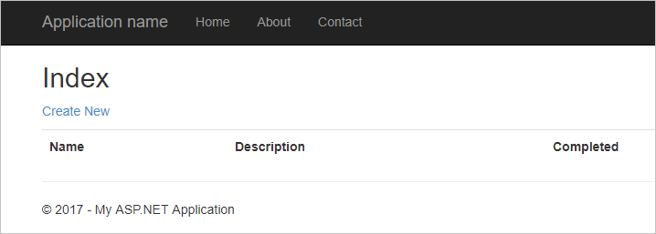

**Adding Items**

Let's put some items into our database so we have something more than an empty grid to look at.

Let's add some code to Azure Cosmos DBRepository and ItemController to persist the record in Azure Cosmos DB.

1. Add the following method to your **DocumentDBRepository** class.

Copy

public static async Task<Document> CreateItemAsync(T item)

{

return await client.CreateDocumentAsync(UriFactory.CreateDocumentCollectionUri(DatabaseId, CollectionId), item);

}

This method simply takes an object passed to it and persists it in Azure Cosmos DB.

1. Open the ItemController.cs file and add the following code snippet within the class. This is how ASP.NET MVC knows what to do for the **Create** action. In this case just render the associated Create.cshtml view created earlier.

Copy

[ActionName("Create")]

public async Task<ActionResult> CreateAsync()

{

return View();

}

We now need some more code in this controller that will accept the submission from the **Create** view.

1. Add the next block of code to the ItemController.cs class that tells ASP.NET MVC what to do with a form POST for this controller.

Copy

[HttpPost]

[ActionName("Create")]

[ValidateAntiForgeryToken]

public async Task<ActionResult> CreateAsync([Bind(Include = "Id,Name,Description,Completed")] Item item)

{

if (ModelState.IsValid)

{

await DocumentDBRepository<Item>.CreateItemAsync(item);

return RedirectToAction("Index");

}

return View(item);

}

This code calls in to the DocumentDBRepository and uses the CreateItemAsync method to persist the new todo item to the database.

**Security Note**: The **ValidateAntiForgeryToken** attribute is used here to help protect this application against cross-site request forgery attacks. There is more to it than just adding this attribute, your views need to work with this anti-forgery token as well. For more on the subject, and examples of how to implement this correctly, please see [Preventing Cross-Site Request Forgery](https://go.microsoft.com/fwlink/?LinkID=517254). The source code provided on [GitHub](https://github.com/Azure-Samples/documentdb-net-todo-app) has the full implementation in place.

**Security Note**: We also use the **Bind** attribute on the method parameter to help protect against over-posting attacks. For more details please see [Basic CRUD Operations in ASP.NET MVC](https://go.microsoft.com/fwlink/?LinkId=317598).

This concludes the code required to add new Items to our database.

**Editing Items**

There is one last thing for us to do, and that is to add the ability to edit **Items** in the database and to mark them as complete. The view for editing was already added to the project, so we just need to add some code to our controller and to the **DocumentDBRepository** class again.

1. Add the following to the **DocumentDBRepository** class.

Copy

public static async Task<Document> UpdateItemAsync(string id, T item)

{

return await client.ReplaceDocumentAsync(UriFactory.CreateDocumentUri(DatabaseId, CollectionId, id), item);

}

public static async Task<T> GetItemAsync(string id)

{

try

{

Document document = await client.ReadDocumentAsync(UriFactory.CreateDocumentUri(DatabaseId, CollectionId, id));

return (T)(dynamic)document;

}

catch (DocumentClientException e)

{

if (e.StatusCode == HttpStatusCode.NotFound)

{

return null;

}

else

{

throw;

}

}

}

The first of these methods, **GetItem** fetches an Item from Azure Cosmos DB which is passed back to the **ItemController** and then on to the **Edit** view.

The second of the methods we just added replaces the **Document** in Azure Cosmos DB with the version of the **Document** passed in from the **ItemController**.

1. Add the following to the **ItemController** class.

Copy

[HttpPost]

[ActionName("Edit")]

[ValidateAntiForgeryToken]

public async Task<ActionResult> EditAsync([Bind(Include = "Id,Name,Description,Completed")] Item item)

{

if (ModelState.IsValid)

{

await DocumentDBRepository<Item>.UpdateItemAsync(item.Id, item);

return RedirectToAction("Index");

}

return View(item);

}

[ActionName("Edit")]

public async Task<ActionResult> EditAsync(string id)

{

if (id == null)

{

return new HttpStatusCodeResult(HttpStatusCode.BadRequest);

}

Item item = await DocumentDBRepository<Item>.GetItemAsync(id);

if (item == null)

{

return HttpNotFound();

}

return View(item);

}

The first method handles the Http GET that happens when the user clicks on the **Edit**link from the **Index** view. This method fetches a [**Document**](https://msdn.microsoft.com/library/azure/microsoft.azure.documents.document.aspx) from Azure Cosmos DB and passes it to the **Edit** view.

The **Edit** view will then do an Http POST to the **IndexController**.

The second method we added handles passing the updated object to Azure Cosmos DB to be persisted in the database.

That's it, that is everything we need to run our application, list incomplete **Items**, add new **Items**, and edit **Items**.

**Step 6: Run the application locally**

To test the application on your local machine, do the following:

1. Hit F5 in Visual Studio to build the application in debug mode. It should build the application and launch a browser with the empty grid page we saw before:

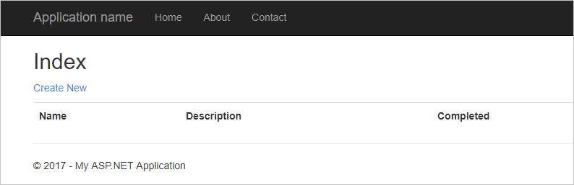

1. Click the **Create New** link and add values to the **Name** and **Description** fields. Leave the **Completed** check box unselected otherwise the new **Item** will be added in a completed state and will not appear on the initial list.

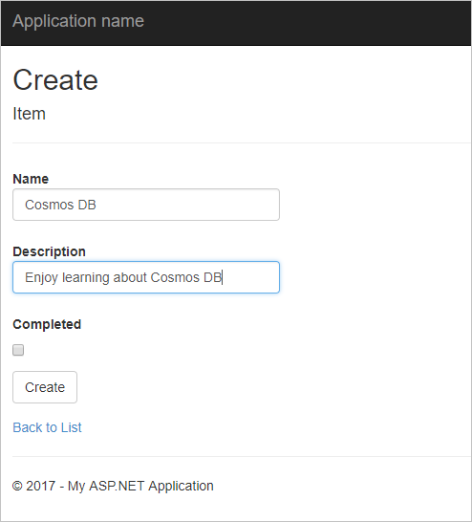

1. Click **Create** and you are redirected back to the **Index** view and your **Item** appears in the list.

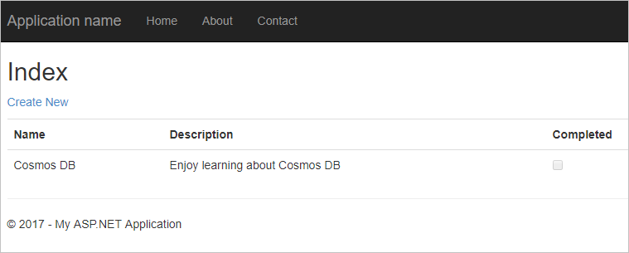

Feel free to add a few more **Items** to your todo list.

1. Click **Edit** next to an **Item** on the list and you are taken to the **Edit** view where you can update any property of your object, including the **Completed** flag. If you mark the **Complete** flag and click **Save**, the **Item** is removed from the list of incomplete tasks.

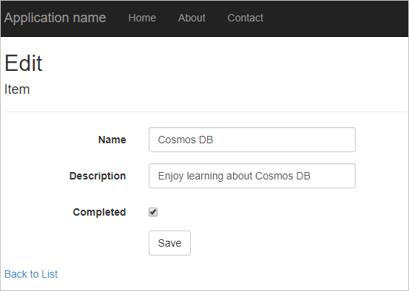

1. Once you've tested the app, press Ctrl+F5 to stop debugging the app. You're ready to deploy!

**Step 7: Deploy the application to Azure App Service**

Now that you have the complete application working correctly with Azure Cosmos DB we're going to deploy this web app to Azure App Service.

1. To publish this application all you need to do is right-click on the project in **Solution Explorer** and click **Publish**.

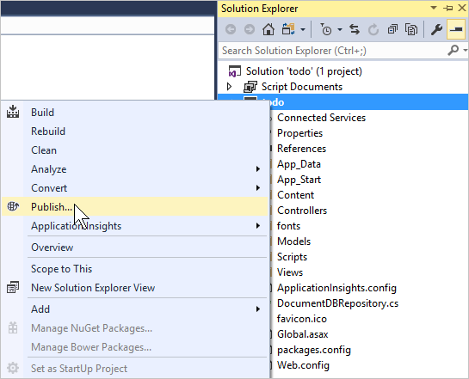

1. In the **Publish** dialog box, click **Microsoft Azure App Service**, then select **Create New** to create an App Service profile, or click **Select Existing** to use an existing profile.

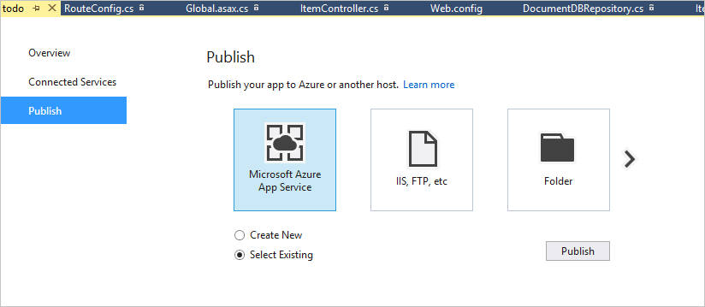

1. If you have an existing Azure App Service profile, enter your subscription name. Use the **View** filter to sort by resource group or resource type, then select your Azure App Service.

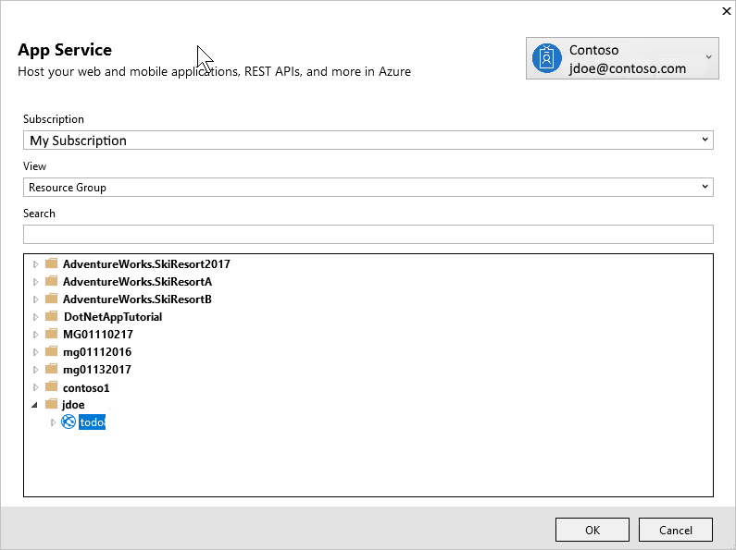

1. To create a new Azure App Service profile, click **Create New** in the **Publish** dialog box. In the **Create App Service** dialog, enter your Web App name and appropriate subscriptio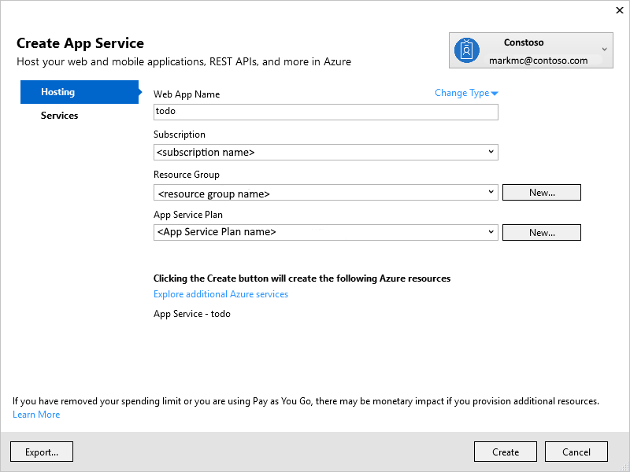n, resource group, and App Service plan, then click **Create**.

In a few seconds, Visual Studio will finish publishing your web application and launch a browser where you can see your handiwork running in Azure!